Java Object-Oriented Programming Experimental Report
NO: Experiment 7 Experiment name：Object-Oriented Design
Student ID | 1607052230 | Name | 邱冠霖 | Class |  | 16软工1班
Location | 实1-218 | Teacher | 唐朝辉 | Time |  | 20180503
1.Experimental purposes and requirements
1.1 One-Dimensional Arrays
1.2 Arrays of Objects
1.3 Variable Length Parameter Lists
1.4 ArrayList Class
1.5 Mouse Events
2.Experimental equipment (environment) and requirements
2.1 Eclipse
2.2 Window XP
3.Lab Exercises(Please see Lab Manual)
3.1 Tracking Sales
3.2 Grading Quizzes (Choose to do)
3.3 Reversing an Array(Choose to do)
3.4 Adding To and Removing From an Integer List(Choose to do)
3.5 A Shopping Cart (Choose to do)
3.6 Averaging Numbers (Choose to do)
3.7 Exploring Variable Length Parameter Lists
3.8 Magic Squares(Choose to do)
3.9 A Shopping Cart Using the ArrayList Class (Choose to do)
3.10 A Polygon Person(Choose to do)
3.11 An Array of Radio Buttons
3.12 Drawing Circles with Mouse Clicks
3.13 Moving Circles with the Mouse(Choose to do)
3.14 Moving a Stick Figure(Choose to do)
4.Experimental results and data processing

5.Analysis and discussion
没有遇到什么问题，源代码都放在github上，欢迎讨论
https://github.com/kong1414/JavaLesson.git
6.Teacher Reviews  Signature：  Date： |  |  |  |  | Score:

Experimental Report List
1 Tracking Sales
1) Source code list

package chapter07;
import java.util.Scanner;
/**
* @Description:
* @Author: QiuGuanLin
* @Date: 2018/4/13 10:44
*/
public class Sales {
public static void main(String[] args) {
Scanner scan = new Scanner(System.in);
final int SALESPEOPLE = 5;
int sum;
int maxtemp = 0;
int mintemp = 0;
int max = Integer.MIN_VALUE;
int min = Integer.MAX_VALUE;
System.out.println("请输入人数");
3
int[] sales = new int[scan.nextInt()];
for (int i = 0; i < sales.length; i++) {
System.out.print("Enter sales for salesperson " + i + ": ");
sales[i] = scan.nextInt();
if (max < sales[i]) {
max = sales[i];
maxtemp = i;
}
if (min > sales[i]) {
min = sales[i];
mintemp = i;
}
}
System.out.println("\nSalesperson Sales");
System.out.println("--------------------");
sum = 0;
for (int i = 0; i < sales.length; i++) {
System.out.println(" " + i + " " + sales[i]);
sum += sales[i];
}
System.out.println("\nTotal sales: " + sum);
System.out.println("平均值为" + (sum / sales.length));
System.out.println("salesperon" + maxtemp + "had the highest sale with $" + max);
System.out.println("salesperon" + mintemp + "had the lowest sale with $" + min);
System.out.println("请输入销售额");
int wanto = scan.nextInt();
int temp = 0;
for (int i = 0; i < sales.length; i++) {
if (sales[i] > wanto) {
System.out.println(" " + i + " " + sales[i]);
temp++;
}
}
System.out.println("超过人数为" + temp);
System.out.println("ID修改后");
for (int i = 0; i < sales.length; i++) {
System.out.println(" " + (i + 1) + " " + sales[i]);
}
}
}

2) Results data processing
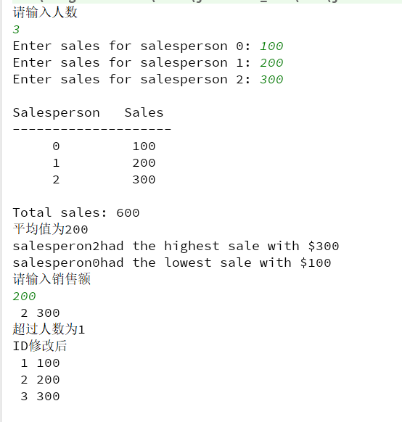

3) Answer questions

4)Error Analysis and Discussion

7 Exploring Variable Length Parameter Lists
1) Source code list
package chapter07;
import java.util.Scanner;
/**
* @Description:
* @Author: QiuGuanLin
* @Date: 2018/5/4 10:20
*/
public class Parameters {
//-----------------------------------------------
// Calls the average and minimum methods with
// different numbers of parameters.
//-----------------------------------------------
public static void main(String[] args) {
double mean1, mean2, mean3, mean4;
int[] means = new int[20];
Scanner sc = new Scanner(System.in);
mean1 = average(42, 69, 37);
mean2 = average(35, 43, 93, 23, 40, 21, 75);
mean3 = average(13);
System.out.println("mean1 = " + mean1);
System.out.println("mean2 = " + mean2);
System.out.println("mean3 = " + mean3);
int num = 0;
do {
int temp = sc.nextInt();
if (temp < 0) {
break;
}
means[num++] = temp;
} while (num < 20);
mean4 = average(means);
int min = minimum(means);
System.out.println("mean4 = " + mean4);
System.out.println("min = " + min);
}
//----------------------------------------------
// Returns the average of its parameters.
//----------------------------------------------
public static double average(int... list) {
double result = 0.0;
if (list.length != 0) {
int sum = 0;
for (int num : list) {
sum += num;
}
result = (double) sum / list.length;
}
return result;
}
/**
* 求数组中最小值
*
* @param list
* @return
*/
public static int minimum(int... list) {
int min = Integer.MAX_VALUE;
if (list.length != 0) {
for (int num : list) {
if (num < min) {
min = num;
}
}
}
return min;
}
}

2) Results data processing
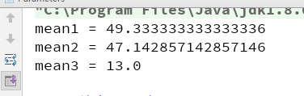
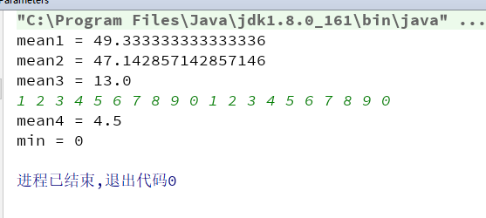

3) Answer questions

4)Error Analysis and Discussion

11 An Array of Radio Buttons
1) Source code list
package chapter07;
import javax.swing.*;
/**
* @Description:
* @Author: QiuGuanLin
* @Date: 2018/5/4 10:35
*/
public class ColorOptions {
// -------------------------------------------------------------
// Creates and presents the frame for the color change panel.
// -------------------------------------------------------------
public static void main(String[] args) {
JFrame colorFrame = new JFrame("Color Options");
colorFrame.setDefaultCloseOperation(JFrame.EXIT_ON_CLOSE);
ColorOptionsPanel panel = new ColorOptionsPanel();
colorFrame.getContentPane().add(panel);
colorFrame.pack();
// colorFrame.setSize(400, 400);
colorFrame.setVisible(true);
}
}
package chapter07;
import javax.swing.*;
import java.awt.*;
import java.awt.event.ActionEvent;
import java.awt.event.ActionListener;
/**
* @Description:
* @Author: QiuGuanLin
* @Date: 2018/5/4 10:35
*/
public class ColorOptionsPanel extends JPanel {
private final int WIDTH = 350, HEIGHT = 100, FONT_SIZE = 20;
private final int NUM_COLORS = 5;
private Color[] color = new Color[NUM_COLORS];
private JLabel heading;
private JRadioButton[] colorButton = new JRadioButton[NUM_COLORS];
// ------------------------------------------------------------------
// Sets up a panel with a label at the top and a set of radio buttons
// that control the background color of the panel.
// ------------------------------------------------------------------
public ColorOptionsPanel() {
// Set up heading and colors
heading = new JLabel("Choose the background color!");
heading.setFont(new Font("Helvetica", Font.BOLD, FONT_SIZE));
color[0] = Color.yellow;
color[1] = Color.cyan;
color[2] = Color.red;
color[3] = Color.green;
color[4] = Color.magenta;
// Instantiate a ButtonGroup object and a ColorListener object
ButtonGroup buttonGroup = new ButtonGroup();
ColorListener colorListener = new ColorListener();
colorButton[0] = new JRadioButton("yellow");
colorButton[1] = new JRadioButton("cyan");
colorButton[2] = new JRadioButton("red");
colorButton[3] = new JRadioButton("green");
colorButton[4] = new JRadioButton("magenta");
for (int i = 0; i < NUM_COLORS; i++) {
colorButton[i].addActionListener(colorListener);
buttonGroup.add(colorButton[i]);
this.add(colorButton[i]);
}
// Set up the panel
add(heading);
setBackground(Color.yellow);
setPreferredSize(new Dimension(WIDTH, HEIGHT));
// Group the radio buttons, add a ColorListener to each,
// set the background color of each and add each to the panel.
this.setBackground(Color.white);
}
// **************************************************************
// Represents the listener for the radio buttons.
// **************************************************************
private class ColorListener implements ActionListener {
// --------------------------------------------------------
// Updates the background color of the panel based on
// which radio button is selected.
// --------------------------------------------------------
@Override
public void actionPerformed(ActionEvent event) {
Object source = event.getSource();
for (int i = 0; i < color.length; i++) {
if (source == colorButton[i]) {
setBackground(color[i]);
break;
}
}
}
}
}

2) Results data processing
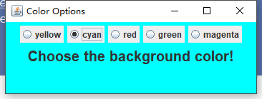
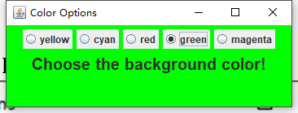

3) Answer questions

4)Error Analysis and Discussion

12 Drawing Circles with Mouse Clicks
1) Source code list
package chapter07;
import javax.swing.*;
/**
* @Description:
* @Author: QiuGuanLin
* @Date: 2018/5/4 11:02
*/
public class Circles {
//-----------------------------------------------------------------
// Creates and displays the application frame.
//-----------------------------------------------------------------
public static void main(String[] args) {
JFrame circlesFrame = new JFrame("Circles");
circlesFrame.setDefaultCloseOperation(JFrame.EXIT_ON_CLOSE);
circlesFrame.getContentPane().add(new CirclePanel());
circlesFrame.pack();
circlesFrame.setVisible(true);
}
}

package chapter07;
import java.awt.*;
import java.util.Random;
/**
* @Description:
* @Author: QiuGuanLin
* @Date: 2018/5/4 11:02
*/
public class Circle {
private int centerX, centerY;
private int radius;
private Color color;
static Random generator = new Random();
//---------------------------------------------------------
// Creates a circle with center at point given, random radius and color
// -- radius 25..74
// -- color RGB value 0..16777215 (24-bit)
//---------------------------------------------------------
public Circle(Point point) {
radius = Math.abs(generator.nextInt()) % 50 + 25;
color = new Color(Math.abs(generator.nextInt()) % 16777216);
centerX = point.x;
centerY = point.y;
}
//---------------------------------------------------------
// Draws circle on the graphics object given
//---------------------------------------------------------
public void draw(Graphics page) {
page.setColor(color);
page.fillOval(centerX - radius, centerY - radius, radius * 2, radius * 2);
}
public void move(Point p) {
centerX = p.x;
centerY = p.y;
}
public boolean isInside(Point p) {
if (Math.sqrt((centerX - p.x) * (centerX - p.x) - (centerY - p.y) * (centerY - p.y)) - radius <= 0) {
return true;
}
return false;
}
}

package chapter07;
import javax.swing.*;
import java.awt.*;
import java.awt.event.*;
/**
* @Description:
* @Author: QiuGuanLin
* @Date: 2018/5/4 11:03
*/
public class CirclePanel extends JPanel {
private final int WIDTH = 600, HEIGHT = 400;
private Circle circle;
//----------------------------------------------------------------
// Sets up this panel to listen for mouse events. //----------------------------------------------------------------
public CirclePanel() {
addMouseListener(new CirclesListener());
setPreferredSize(new Dimension(WIDTH, HEIGHT));
}
//----------------------------------------------------------------
// Draws the current circle, if any.
//----------------------------------------------------------------
@Override
public void paintComponent(Graphics page) {
super.paintComponent(page);
if (circle != null) {
circle.draw(page);
}
}
//*****************************************************************
// Represents the listener for mouse events.
//*****************************************************************
private class CirclesListener implements MouseListener {
//-------------------------------------------------------------
// Creates a new circle at the current location whenever the
// mouse button is pressed and repaints.
//-------------------------------------------------------------
@Override
public void mousePressed(MouseEvent event) {
if (circle == null) {
circle = new Circle(event.getPoint());
} else {
if (circle.isInside(event.getPoint())) {
circle = null;
} else {
circle.move(event.getPoint());
}
}
repaint();
}
//----------------------------------------------------------------
// Provide empty definitions for unused event methods. //----------------------------------------------------------------
@Override
public void mouseClicked(MouseEvent event) {
}
@Override
public void mouseReleased(MouseEvent event) {
}
@Override
public void mouseEntered(MouseEvent event) {
}
@Override
public void mouseExited(MouseEvent event) {
}
}
}

2) Results data processing
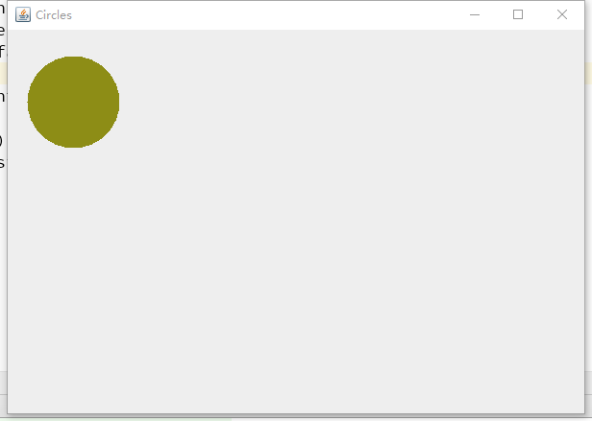
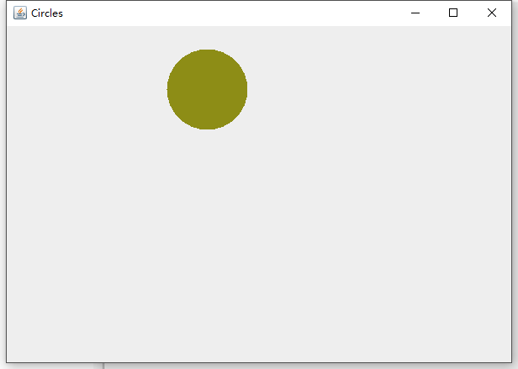
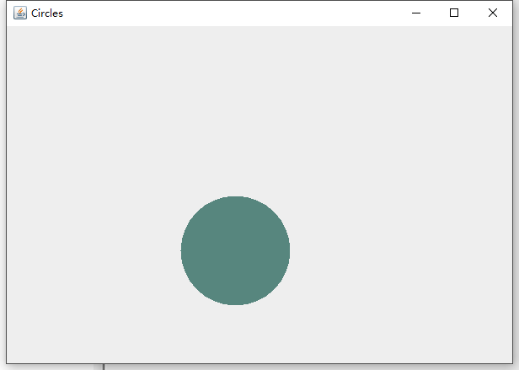

3) Answer questions

4)Error Analysis and Discussion

1 Tracking Sales
1) Source code list

2) Results data processing

3) Answer questions

4)Error Analysis and Discussion

